

(LAB TASK)

Department of Computer Science
Air University, Islamabad


Visual Programming

ID | NAME
2500620 | Ayesha Awan

LAB TASK 1 - STUDENT PROFILE COMPONENT

StudentProfile.razor Code:

<h3>Student Profile</h3>
<p>Name: @StudentName</p>
<p>Registration No: @RegistrationNo</p>
<p>Department: @Department</p>
<p>Semester: @Semester</p>

@code {
[Parameter]
public string StudentName { get; set; } = "";

[Parameter]
public string RegistrationNo { get; set; } = "";

[Parameter]
public string Department { get; set; } = "";

[Parameter]
public string Semester { get; set; } = "";
}

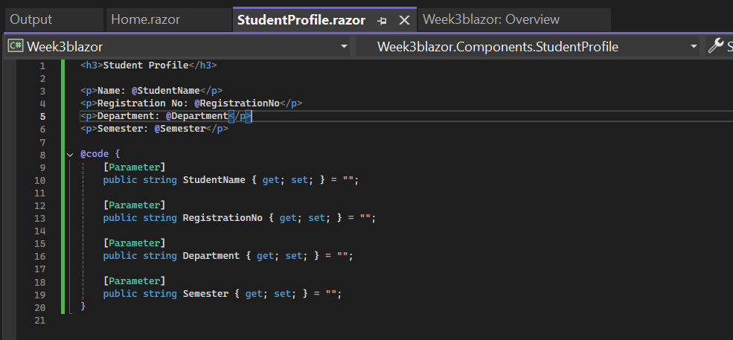

Home.razor Code:
@page "/"
<h1>Student Information</h1>
<StudentProfile StudentName="Muhammad Ali"
RegistrationNo="AU-CS-001"
Department="Computer Science"
Semester="5th" />
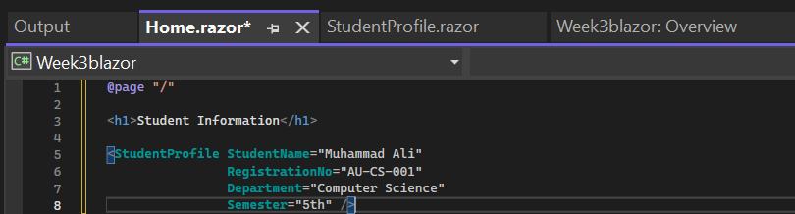

Output:

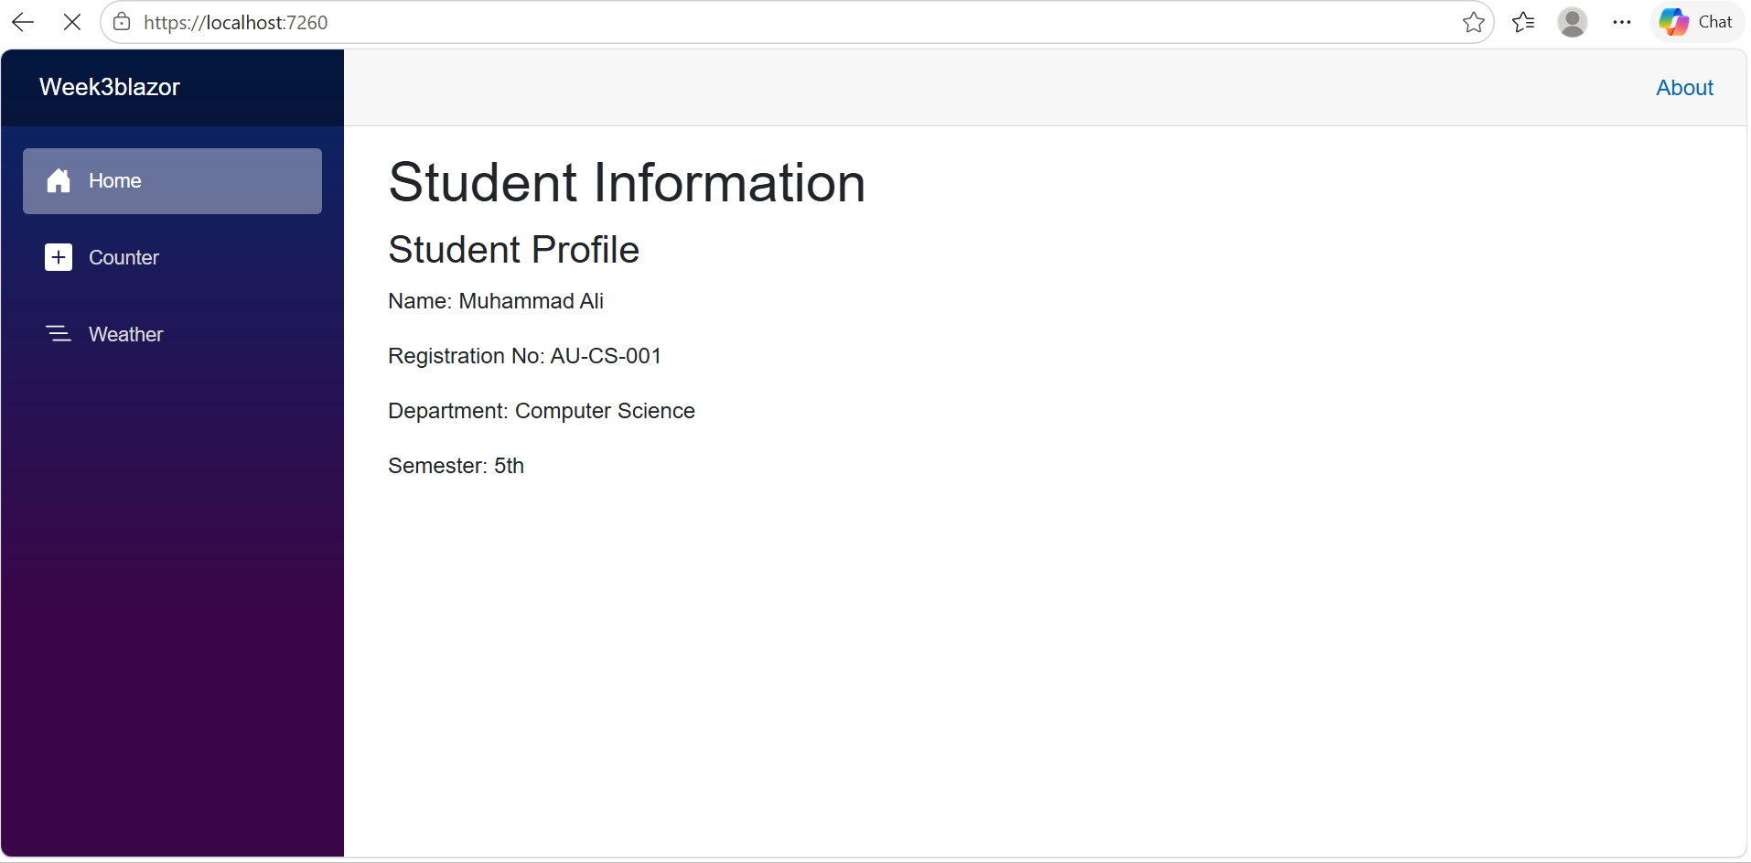
Result:
The StudentProfile component was successfully created and reused in the Home component. The four student parameters were passed from the parent component and displayed correctly.

LAB TASK 2 - REUSABLE COURSE COMPONENT

CourseInfo.razor Code:
<h3>Course Information</h3>
<p>Course Code: @CourseCode</p>
<p>Course Name: @CourseName</p>
<p>Credit Hours: @CreditHours</p>
<p>Instructor: @Instructor</p>
@code {
[Parameter]
public string CourseCode { get; set; } = "";

[Parameter]
public string CourseName { get; set; } = "";

[Parameter]
public int CreditHours { get; set; }

[Parameter]
public string Instructor { get; set; } = "";
}
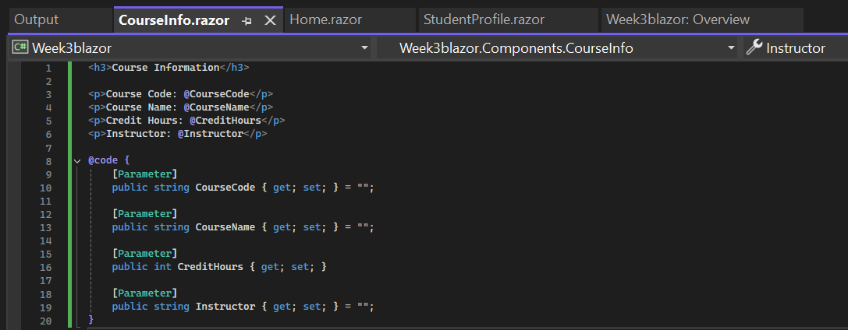

Home.razor Code:
<h2>Courses</h2>
<CourseInfo CourseCode="CS-382L"
CourseName="Visual Programming"
CreditHours="3"
Instructor="Qadeer Yasin" />
<CourseInfo CourseCode="CS-401"
CourseName="Artificial Intelligence"
CreditHours="3"
Instructor="Dr. Ahmed" />
<CourseInfo CourseCode="CS-305"
CourseName="Database Systems"
CreditHours="3"
Instructor="Dr. Ali" />
<hr />

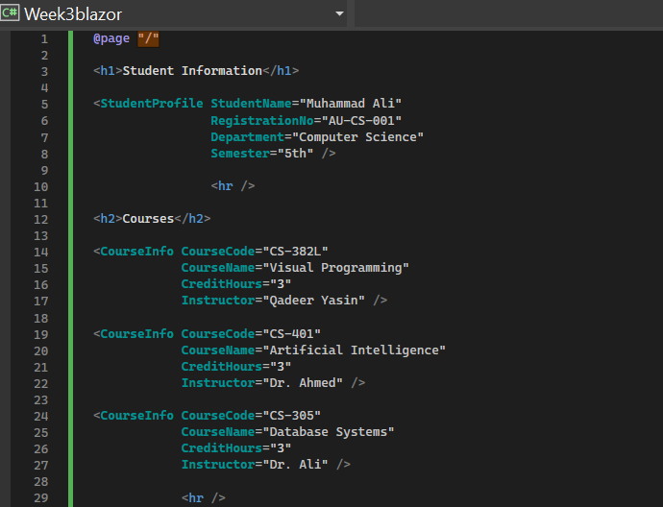

Output:

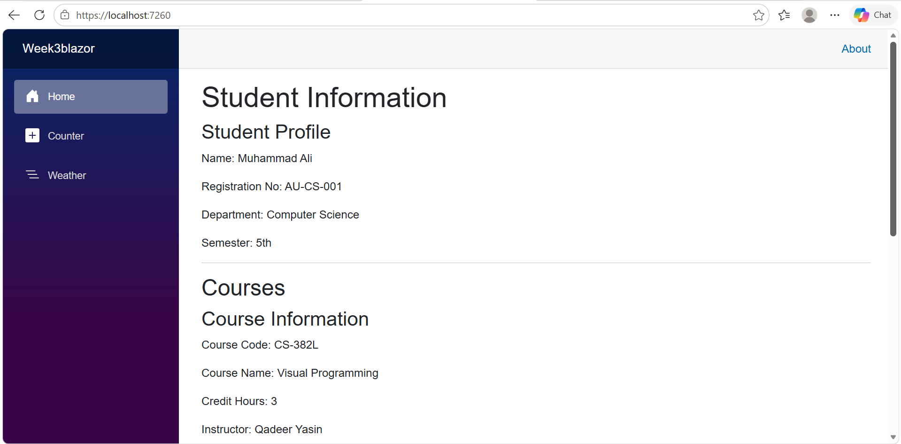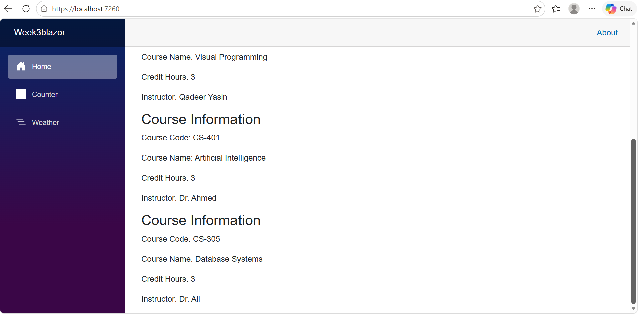
Result:
The CourseInfo component was successfully reused for three different courses. Different parameter values were passed to display each course's information.

LAB TASK 3 - BUTTON EVENT AND COUNTER

Counter.razor Code:
<h3>Counter</h3>
<p>Current Value: @currentValue</p>
<button @onclick="Increase">Increase</button>
<button @onclick="Decrease">Decrease</button>
@code {
private int currentValue = 0;
private void Increase()
{
currentValue++;
}

private void Decrease()
{
currentValue--;
}
}
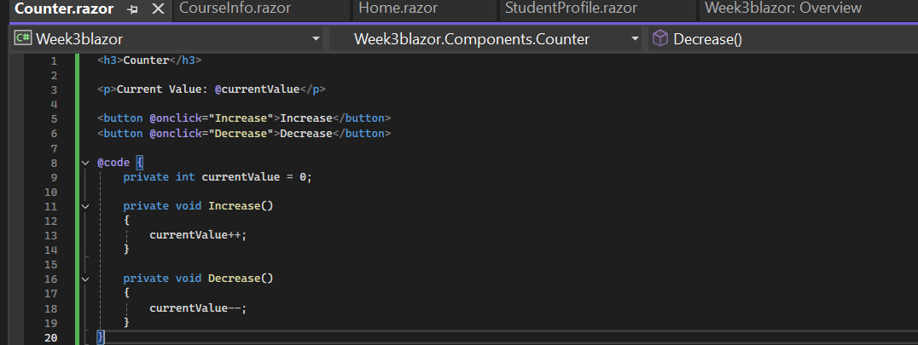

Home.razor Code:
<hr />
<h2>Counter</h2>
<Counter />
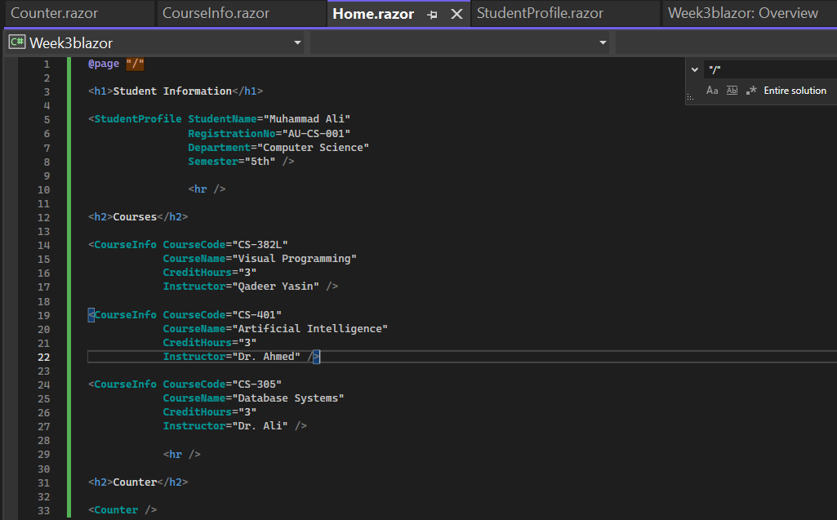

Output:

Initial Counter Value:

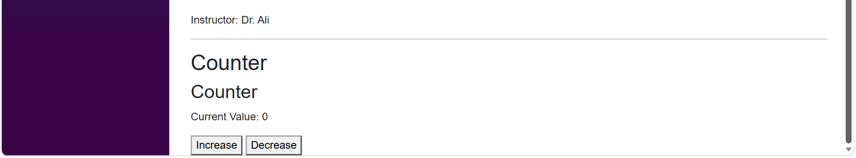

Increase Button:

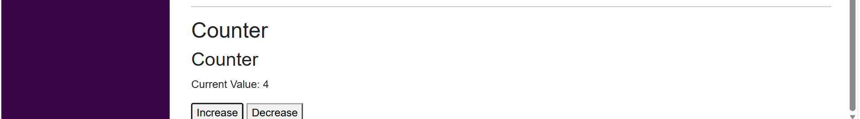

Decrease Button:

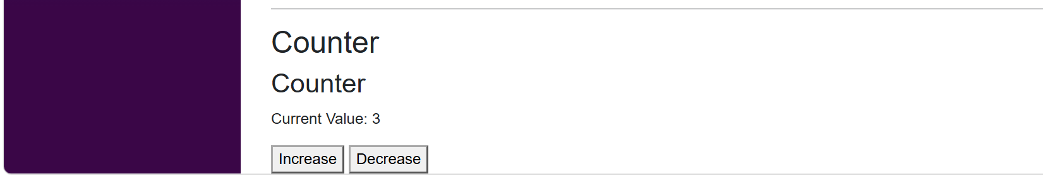
Result:
The counter component was successfully implemented with Increase and Decrease buttons. The value increased and decreased correctly when the respective buttons were clicked.

LAB TASK 4 - COURSE SELECTION USING EVENTCALLBACK

CourseSelector.razor Code:
<h3>Select a Course</h3>
<p>Visual Programming</p>
<button @onclick='() => SelectCourse("Visual Programming")'>Select</button>
<p>Artificial Intelligence</p>
<button @onclick='() => SelectCourse("Artificial Intelligence")'>Select</button>
<p>Database Systems</p>
<button @onclick='() => SelectCourse("Database Systems")'>Select</button>
@code {
[Parameter]
public EventCallback<string> OnCourseSelected { get; set; }
private async Task SelectCourse(string courseName)
{
await OnCourseSelected.InvokeAsync(courseName);
}
}
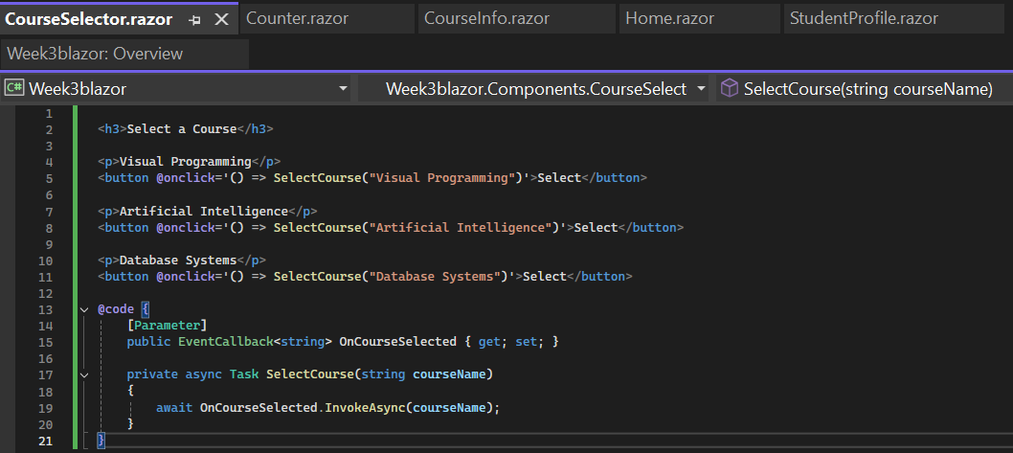

Home.razor Code:
<h1>Course Selection</h1>
<CourseSelector OnCourseSelected="HandleCourseSelected" />
<h3>Selected Course: @selectedCourse</h3>
@code {
private string selectedCourse = "";
private void HandleCourseSelected(string courseName)
{
selectedCourse = courseName;
}
}

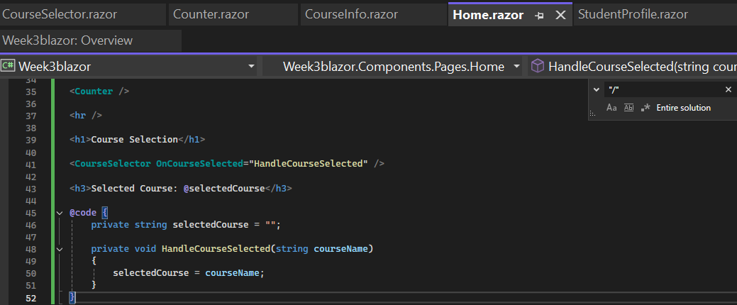

Output:
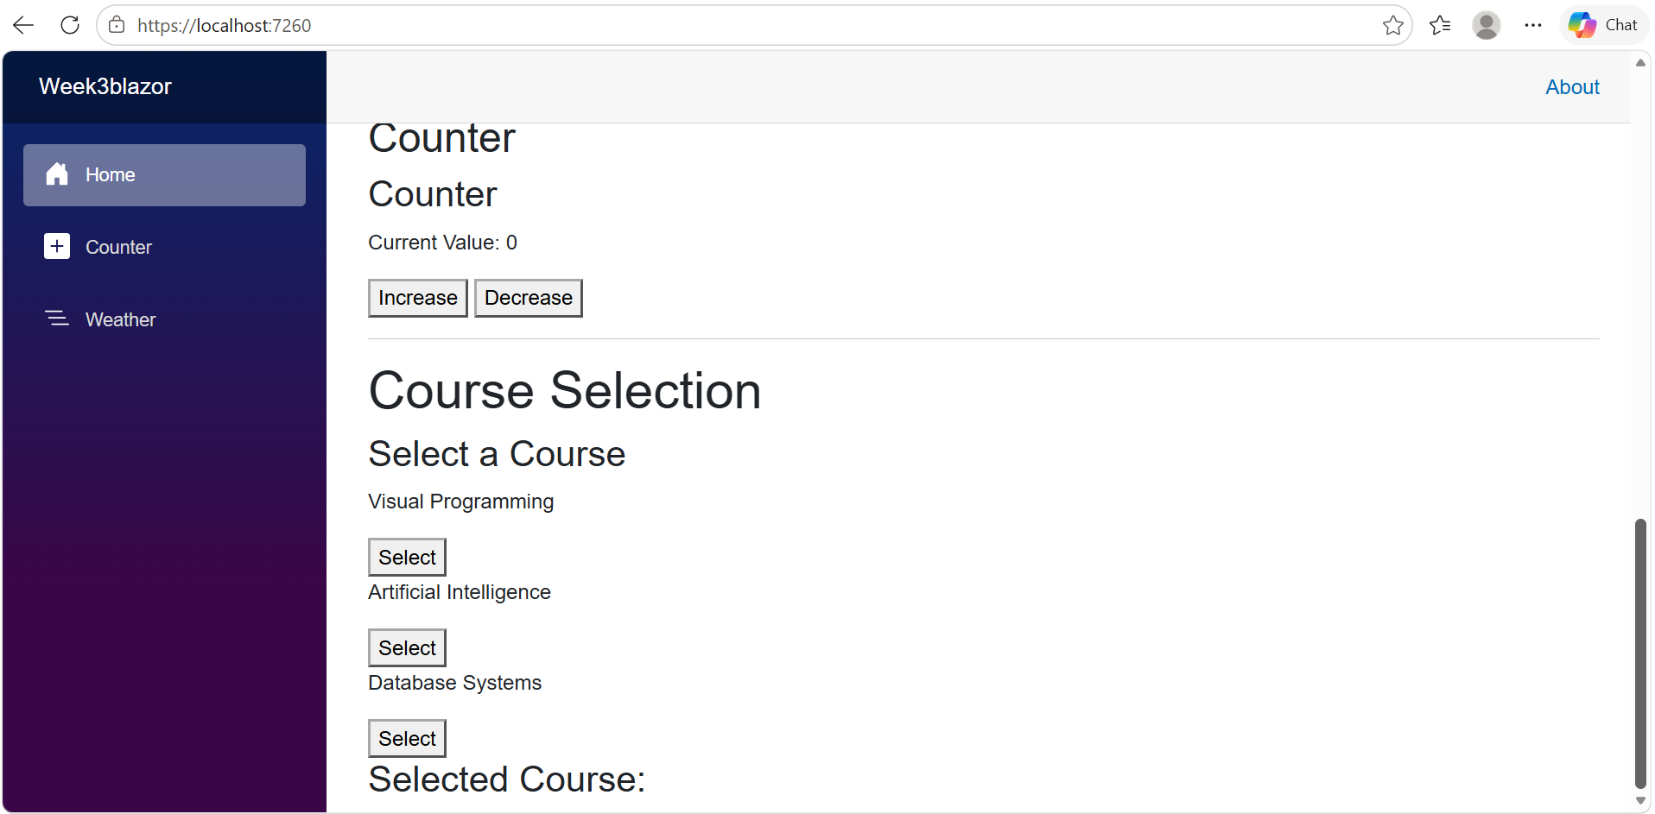

After Selecting a Course:
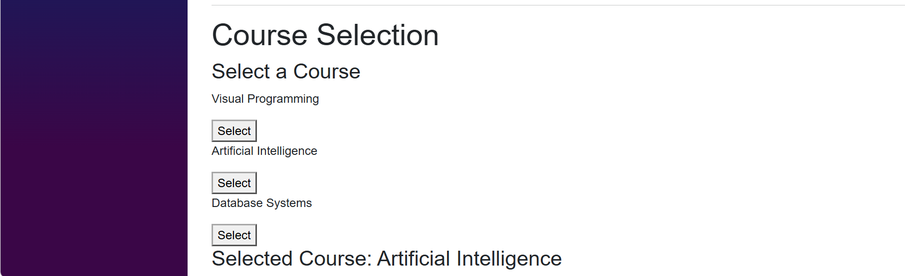

Result:
The EventCallback mechanism was successfully implemented for child-to-parent communication. When a course was selected in CourseSelector, its name was sent to Home.razor and displayed as the selected course.

Conclusion

In this lab, I learned how to create and reuse Razor components in Blazor. I practiced passing data using parameters, handling button click events, and communicating from a child component to a parent component using EventCallback. These concepts helped me understand the basic structure and interactivity of Blazor applications.

